**Class Update and Render**

https://www.youtube.com/watch?v=Wm6Ll7jf4G0&index=48&list=PLRtjMdoYXLf776y4K432eL_qPw4na_py3

**3rd class – Player.h:**

#pragma once

#ifndef PLAYER_H

#define PLAYER_H

#include "SFML/Graphics.hpp"

class Player

{

public:

Player();

~Player();

void update(float dt);

void draw(sf::RenderWindow &window);

private:

sf::Sprite playerSprite;

sf::Texture playerTexture;

};

#endif // !PLAYER_H

**2nd class – Player.cpp:**

#include "stdafx.h"

#include "Player.h"

#include <iostream>

Player::Player()

{

if (!playerTexture.loadFromFile("shape.png"))

{

std::cout << "Could not load texture" << std::endl;

}

playerSprite.setTexture(playerTexture);

}

Player::~Player()

{

}

void Player::update(float dt)

{

}

void Player::draw(sf::RenderWindow &window)

{

window.draw(playerSprite);

}

**1st class – ConsoleApplication2.cpp:**

#include "stdafx.h"

#include "SFML/Graphics.hpp"

#include <iostream>

#include <windows.h>

#include "Player.h"

int main()

{

sf::RenderWindow window (sf::VideoMode(640, 480), "SFML works!");

Player player;

sf::Clock clock;

while (window.isOpen()) {

sf::Event event;

while (window.pollEvent(event))

{

switch (event.type)

{

case sf::Event::Closed:

window.close();

break;

}

}

sf::Time time = clock.getElapsedTime();

player.update(time.asMilliseconds());

clock.restart();

window.clear();

player.draw(window);

window.display();

}

}

**Result**

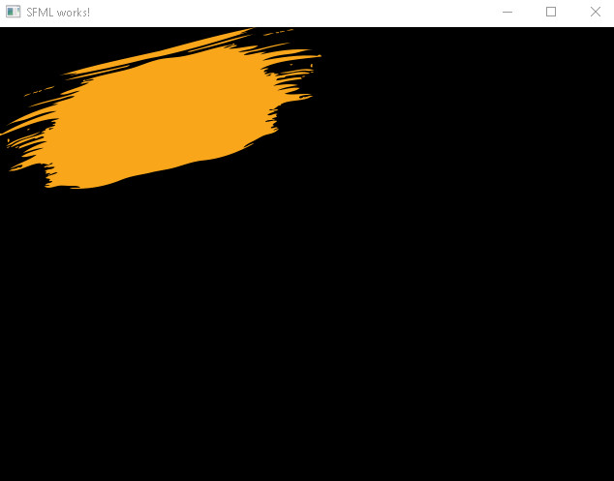

(Nothing special here)